GAD323 Readings & Assignments: Week 2

Week 2 Reading
Complete the following reading early in the week:
- Week 2 online lectures
- The following chapters from the text Storyboards, Motion in Art, by Mark Simon:
  - Chapter 19: Previz
  - Chapter 20: Styles
  - Chapter 21: Directing Shots
  - Chapter 22: Working with Directors
  - Chapter 23: Screen Direction
  - Chapter 24: Staging and Composition
  - Chapter 25: References and Research
  - Chapter 26: Illustrated Camera Techniques
  - Chapter 27: Numbering
Week 2 Assignments Overview
Assignment Summary: | Due Date
Assignment 1: Discussion Questions | Saturday, May 23, 2009
Assignment 2: Web Quest | Saturday, May 23, 2009
Assignment 3: Final Project: Composing Dynamic Shots | Sunday, May 24, 2009
Remember that all assignment details can be found on the assignment pages located throughout the week. Go to those specific pages for direction on how to complete each individual assignment.

Week 2 Overview
The very first step in production, be it feature films, animations, or video games, is an idea that's formed in someone's head. As you read last week, these ideas are appropriated from a number of sources—dreams, myths, memory, and personal experience. These ideas then embark on an arduous journey: that of becoming a storyboard!
A storyboard includes information about the dialogue, the location of the scene, and even descriptions of the characters. Being a major part of an animated production, a storyboard is usually revised several times. This week you'll learn about storyboarding for games.
It's been said that for every film made there are actually three films being created; the first begins in the scriptwriter's mind, the second is the story the writer puts on paper, and the third is the film as seen by the audience. This notion also holds true for films, animations, and video games. However in addition to a good storyboard, films and video games need directing skills and fresh photography, elements that we'll discuss in this week's lectures.
Learning Outcomes:
• Synthesize information from diverse sources for project purposes.
• Acquire knowledge and information necessary to accomplish a professional product through reference and research.
• Demonstrate location development through the use of perspective and staging.
• Demonstrate the use of correct terminology and formats associated with preproduction instructions.
• Keep an Idea Journal and sketchbooks in preparation for thumbnails and model sheets for all projects to establish professional preplanning skills.
• Develop skills using pens, markers, colored pencils and other media to create professional presentations and animation storyboards.

Drafting a Storyboard for a Video Game
The task of storyboarding is often a daunting one, especially when you think that a three-minute film could require well over a hundred drawings. A storyboard for a video game requires even more drawings because of its interactive nature—player inputs give rise to multiple possibilities. Moreover, a dynamic storyboard should have an interesting composition, good staging, and clear drawings. This is why it's so important to create drawings quickly and efficiently.
While each storyboard artist has a unique approach, many prefer to begin their process on paper, creating several fast sketches of different framing possibilities. These are quick sketches that are not intended to be drawn "on model," but ones that can be further refined and scanned later in the process. So if you're thinking of starting rough, just be sure that your drawings can be scanned at any time so that you can refine your work on the computer. This way you can save time and extra work!
Initially your characters and sets can be drawn of primitive shapes. And it's quite all right to see scribbles and eraser marks; your primary concern should be to show camera angles, framing, and continuity. Remember the difference between sketching and drawing—roughly sketch the action first rather than drawing it in detail. You will have plenty of time for details as you begin working on model sheets and production stills.
Try to reuse your drawings as much as possible to cut back work on backgrounds and character drawings. If you have different elements that you've already used, layer them in Photoshop for lettering, clean up, and blurring.

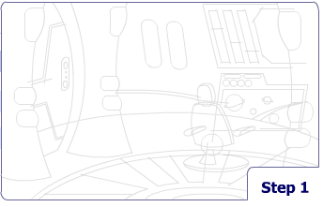
Drafting a Layout
Drafting a storyboard for a videogame – what part of the layout should you start with?

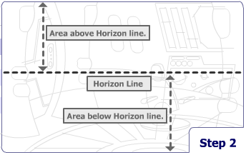
Step 1: Begin with a rough layout sketch. Don’t worry about the border of the picture at this stage, you can adjust these elements later when your drawing is roughed out.

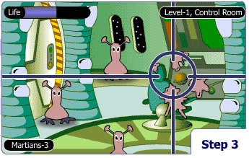
Step 2: The fist line line in your layout sketch is the horizon line that establishes the eye level. Keeping most of the environment above the horizon line will ensure that the eye level is low to the ground. However if you want an aerial view, keep your environment below the horizon line.

Step 3: Consider the dimensions of the environment in your layout since the relationship between the floor, ceiling, and horizon line will ultimately determine your audiences point of view.

Design for Video Game Layout

Once you are ready with a storyboard, you can choose to present it in one of several formats. If you have to show the storyboard to a client, you can create a presentation board in which you can render your drawings accurately, but not including every camera angle and movement. If you create it for actual production, however, you can use a production board in which you can include all aspects of your scene and sometimes even devote several drawings of the same shot to show different stages of action. This format also affords you the possibility to use rough drawings. However, if you want to design a layout for the print medium, you can use highly rendered boards and images called Comps. And finally, if you want your storyboards shot with the soundtrack you can use animatics to give the client an idea of the pacing.
Imagine you had to storyboard the scene of a person handing a briefcase to another on a very crowded street. How will you design the scene visually? How about starting with a wide, high-angle shot of the crowded street, moving to a series of individual medium shots of the two characters walking, and then using a close-up of the briefcase passing between them? Wouldn't this be much better than using a straight-on medium shot of the exchange?

When you compose your scenes, always consider how you can best showcase the action within them. But that's not all. Here are some crucial aspects of visual design that you should remember:
- It's best to vary your shots to keep the screen interesting.
- Try to utilize foreground, middle ground, and background elements in your scenes. This helps to give your shots depth.
- Try to avoid positioning characters and objects against the tangents of the frame. Giving them some breathing room will help your shots to be less constricting.
- Make sure each individual picture has a strong composition and balance that illustrates the action.
- Try to make the cumulative effect of all pictures in the storyboard tell the story with no explanation. The storyboard should convey the story all on its own.

Basic Shot Composition
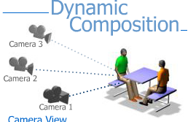
In addition to layout and good visual design, the composition of individual shots can also convey much information about the perspective and emotion of your scene. Among the various categories of shots that give important information about the scene are:
- A point of view shot.
- An over the shoulder shot.
- An establishing shot.
- A birds-eye shot.

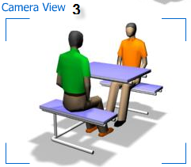
Apart from composing shots to illustrate a certain perspective of the scene, it is also important to consider the distance that the camera should be from a scene. In this regard, types of shots include the close-up, the medium shot, and the wide shot, and variations of each of kind.

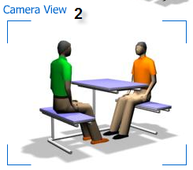
Typically a wide shot is used for establishing a location or to show the relative placement of characters and objects. A wide shot is good for establishing a clear picture of where objects are located in relation to one another, but usually doesn't work for illustrating complex emotion or acting unless it includes broad movement, such as cars racing down a street in a high-speed chase.
A medium shot is more intimate, and allows the audience to see facial expressions and details in props and backgrounds. A medium shot can include more than one character at a time, and can also show limited action within the frame.
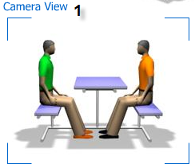
The close-up is an emotional shot. It is very good for showing subtle shifts in facial expressions, or to show important conceptual details when used as a cutaway. For example, if you want to illustrate a scene of a bomb squad trying to diffuse a bomb, you might cut to an extreme close-up of the officer's hands working on the mechanics of the explosive. Close-ups can only show a very limited amount of action due to limited space.

The Golden Mean
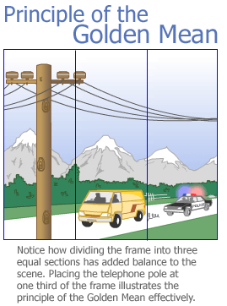
From a graphic standpoint, it is always good to show diagonals in your compositions. This happens naturally when you use a low or high angle camera for a scene, but can also be achieved by rotating the camera so that the horizon line is at a slight diagonal. When you compose in depth or use foreshortening, the perspective adds diagonals to the scene naturally.
Many artists use the "golden mean" in their compositions. The golden mean is an image in which the frame is divided into one third and two thirds, and is widely used because it achieves a natural balance in the frame. If you were to compose a shot for a car chase that has a telephone pole at about one third of the frame, you would be using the golden mean. Placing all your characters and objects directly in the center of the frame makes for boring compositions—try to achieve a sense of balance in each frame and find interesting ways of weighting the frame variation.
Also remember to maintain the visual relationships of your scenes. For example if you compose a scene of a couple talking to each other across a table, keep the scenes consistent. If the man is on the left and the woman is on the right in the wide shot, it should remain this way throughout. In composing for editing, it is important that you maintain an imaginary line cutting through the action. Unless you do it the proper way, you must be sure not to cross this line. As soon as you cross over the line, the man will be on the right of the frame and the woman will be on the left. Visually this can be extremely confusing for the audience.

How to Compose for Different Media
There are some minor differences in composing for TV, film, or video games. Notably each format has a different aspect ratio (width:height). Television tends to use a more square-shape format, whereas film uses a wider and more rectangular format. Television composition therefore has broader movements that can easily be viewed in a small format. As video games are made for computer screens, they often follow the television format. Films on the other hand can have more subtle movements because of their large-screen presentation.
Remember that television screens vary in size, so scenes that appear full frame on one TV may be cropped in another. For this reason, animators use field guides—guides that show prominent cutoff points for essential action—when composing scenes. For example a scene may call for a close-up of a character winking at someone off screen; if the character's eye is close to the far side of the frame, the action may not be visible on all TVs.
Usually, a field guide will have a box for the full frame, a slightly smaller box for "action-safe." and an even smaller box for "title-safe." This could make the action vague or confusing, so it is necessary to compose all essential action in the "action" safe box. Title-safe is even smaller as it is critical that every letter be fully readable on the screen.

Staging and Design
Apart from creating interesting shots to tell your story, you can also exploit other attributes of the camera to assist in your visual design. One way is to use camera lenses of various sizes, each denoting separate visual qualities. Lenses are measured in millimeters, and the higher the number of the lens, the greater its ability to magnify the image. A lens that is 120mm is a zoom lens for magnifying things at great distance. A lens of 10mm would be a wide-angle lens.
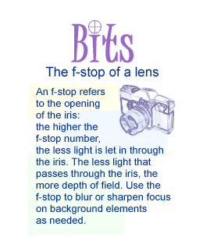
Suppose you create a shot of a man and a woman talking and compose the shot from over the man's shoulder. The zoom lens would make the woman appear very close to the man, but if you shot the same scene with a wide lens, the woman would seem to be farther away. Moreover, the zoom lens would show the man in sharp focus and the woman in soft focus, whereas the wide lens would show both in sharp focus. Lens attributes will actually help you construct spaces within your scenes.
But even as you juggle with balance and composition in your shots, sometimes you will need an actor to be in a certain place for narrative considerations. Stage your actors in a way that makes visual sense with the story, but doesn't block other important aspects of the scene.
Sometimes if several things are happening simultaneously, the logistics of the scene will dictate the actor placement. If you show one character talking to another while a villain sneaks up behind him, it is important to keep both actors in the foreground while the audience is still able to see the villain sneaking up behind them. If you find it impossible to show everything simultaneously, you might need to introduce a camera move within the scene to get all the information across.
As with stage acting, you generally do not want to show characters talking for long periods or blocking other aspects of the scene. It is also necessary to consider if any character movement is necessary. If a character needs to walk across the room to accomplish something, you should make allowances for the character to get to the desired place in a timely manner.
To keep your shots from becoming too busy with details, it is necessary to steer the viewer's eye to the important aspects of the frame. Using selective focus is a good way to center the attention on the action. Another good way of doing this is through selective lighting. If a character is performing subtle tasks, the viewer can't absorb the details if the background is very lush and complex. Rather than simplifying the backgrounds, you can choose to light them in a way that doesn't detract from the main action taking place.

Staging Techniques for Video Games
Video games don't often use the same editing and cinematic layouts as films and animation, and therefore come bundled with their own unique problems. In many cases, player input decides what happens at a given point, so staging possibilities increase as the game progresses.
Games that are created in a three-dimensional (3D) environment give users the ability to change the view as the game progresses. This creates a situation where the staging must be laid out not in terms of a static frame, but with a variable camera that can be revolved in any direction. Often, video games will use virtual "tripwires" to initiate action.
Let's consider the movement of a character through a dungeon with monsters popping out at him from every corner. As long as the character is in the room, the programming is designed to add more monsters periodically to enhance the challenge of the game. Video games create a nonlinear staging, creating events that are set in motion as the player crosses a threshold or interacts with the game. When you design the staging for video games, remember to accommodate the various possibilities of user input into your design.

Conclusion
This week you gathered in-depth information about visual design, storyboarding, spatial connections, scene staging, depth of field, camera angles, types of compositions and camera shots. With this knowledge, you can now create a satisfying flow of shots in your productions, simultaneously maintaining a continuity that will aptly tell the story.
Don't let your work fall into repetitive patterns. Look at the shots on the storyboard, and learn to see each sequence as a complete statement. This way you shall develop an intuitive sense about the overall look of the sequence—an invaluable skill in layout and scene design.

Assignment 1: Discussion Questions
By Saturday, May 23, 2009, go to this Discussion Area and post responses to 2 of the discussion questions assigned by the facilitator. All discussion questions should be posted to the appropriate topic in this Discussion Area.
Before the end of the week, begin commenting on at least 2 of your peers' responses. You can ask technical questions or respond generally to the overall experience. Be objective, clear, and concise. Always use constructive language, even in criticism, to work toward the goal of positive progress. Submit your responses to the appropriate topic in this Discussion Area.
Assignment 1 Grading Criteria and Respective Point Value: | Maximum  Points
Response Criteria
Met the criteria for the correct responses to the questions assigned. | 4
Used vocabulary relevant to the current week's topics—at least four terms. | 4
Participation Criteria
Used vocabulary relevant to the current week's topics—at least four terms. | 4
Participated in the discussion by asking a question, providing a statement of clarification, providing a point of view with rationale, challenging a point of discussion, or making a relationship between one or more points of the discussion. | 4
Justified ideas and responses by using appropriate examples and references from texts, Web sites, and other references or personal experience. | 4
Total: | 20
For assistance with any problems you may have when completing this assignment—OR—to offer your assistance to classmates, please use the Problems and Solutions Discussion area located through the left side navigation link.
1. If you were asked to create a storyboard for a chase scene, which elements would you use for shot composition and why?
2. Choose one of the following moods, and describe how you would go about illustrating that mood through lighting, frame design, camera moves and attributes, and sequential scenes:
happiness
anger
melancholy
surprise
fear
Refer back to C211--storyboarding...that might help
Second Choice...take your scene and describe how you will go about illustrating a mood through lighting, frame design, camera moves and attributes, and sequential scenes.
Do two moods
one mood is yours that you have in mind and the other is choice from the list.
Assignment 2: Web Quest
Visit the following sites and if necessary, do a search within the site to research and collate information on the materials and processes of storyboarding, scene design and layout, production schedules, model sheets and exposure sheets.
- http://www.animationmeat.com/modelsheets/modelsheets.html
- http://www.brianlemay.com/Pages/Tip.html
- http://mag.awn.com/index.php3?ltype=all&sort=date&article_no=1740&page=1
- http://mag.awn.com/index.php3?ltype=all&sort=date&article_no=1377&page=1
- http://www.cartoonnetwork.com/watch/tv_shows/index.html
- http://www.thestoryboardartist.com
Summarize your findings on the concepts used in developing a layout package and the different approaches and materials associated with scene design and layout. How will you incorporate these observations into your Final Project? Choose three techniques/strategies from your research that you will incorporate into your Final Project. Post the summary and your views to this Discussion Area by Saturday, May 23, 2009.
Assignment 2 Grading Criteria and Respective Point Value: | Maximum  Points
Used appropriate vocabulary associated with preproduction instructions. | 4
Submitted an analytical summary of the sites they researched. | 4
Chose at least three techniques to incorporate into your Final Project (3 x 4 for each technique). | 12
Justified selection of the approach logically. | 4
Referred to the URL/example from where they have selected the approach | 4
Total: | 28
For assistance with any problems you may have when completing this assignment—OR—to offer your assistance to classmates, please use the Problems and Solutions Discussion area located through the left side navigation link.

Assignment 3 : Final Project: Composing Dynamic Shots
Be sure to read all my posts in the thread below.
Compose five sequential thumbnail sketches that can be used as a partial storyboard for your final project.
Consider what you learned in the lectures on Staging and Perspective while you complete this assignment.
Post to this Discussion Area by Sunday, May 24, 2009.
Critique 2 based on the following areas:
- How have lighting and color been used to enhance the storyboard?
- Which camera angles have been used and what kind of effect and mood are they trying to create?
- How have the characters been placed in the shots to enhance the layout and scene design?
- Do the shots reflect all the elements of a good design, why or why not? Provide specific suggestions about how the shots can be improved.
Also make revisions in your entries based on the review comments of your peers and resubmit the shots by Tuesday, May 26, 2009 to the W2: Assignment 3 Dropbox.
Assignment 4 Grading Criteria | Maximum  Points
Used traditional and digital tools for the creation of storyboards that illustrate successful narrative and frame design. | 4
Demonstrated examples of successful aesthetics and scene design that can be used in films and video games. | 4
Utilized dynamic compositional elements like depth, camera angles, balance, and character placement in individual frame design (4 x 4 points for each element). | 16
Demonstrated an understanding of narrative through sequential drawings. | 4
Visualized location consistent with the vision and mood of the storyboard proposal. | 4
Adhered to concepts of staging and perspective while developing location. | 4
Total: | 36
For assistance with any problems you may have when completing this assignment—OR—to offer your assistance to classmates, please use the Problems and Solutions Discussion area located through the left side navigation link.
For clarity---these are only thumbnail sketches. Use color, lighting and appropriate camera angles. No text this round. Review your script and using the template posted in the thread, create 5 sketches that are sequential,...leave the rest blank.

Label the thumbnail page like this: w2a3_lastname.jpg
scan at 72 dpi - No docs or pdf files
2 Due Dates: Sunday...for the first round Tuesday...for the second round

